Year: 5/6 A | Autumn 1 | Autumn 2 | Spring 1 | Spring 2 | Summer 1 | Summer 2
Book  (Main Driver Texts) | Beowulf  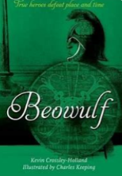  Between Worlds  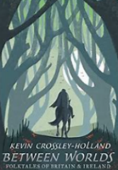 | Floodland  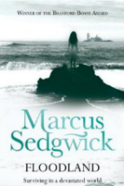  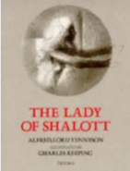  The Lady of Shallot | The Sleeper and the Spindle  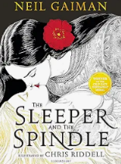  New and Collected Poems for Children  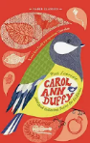 | The Brockenspectre  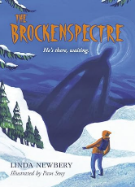  Survivors  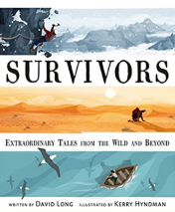 | The Matchbox Diary  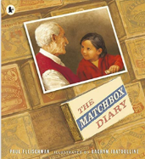  A Story Like the Wind  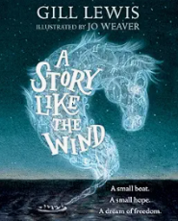 | On the Origin of Species  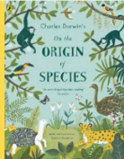  Kensuke’s Kingdom  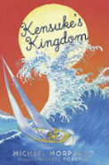
Author | Kevin Crossley Holland | Marcus Sedgwick Tennyson/Keeping | Neil Gaiman  Carol Ann Duffy | Linda Newbery  David Long | Paul Fleischman  Gill Lewis | Sabrina Radeva  Michael Morpurgo
Theme | Anglo-Saxons | Coastal settings/water | Fairy tales and myths | Survival | Migration | Island/water settings
Literary form | Classic fiction | Dystopian fiction  Poetry | Narrative (myths)  Poetry | Modern Fiction  Non-fiction | Picture Book  Fiction | Non-fiction  fiction
Linked texts | Monster Slayer  Anglo Saxon Boy (f)  The Genius of the Anglo-Saxons (nf)  Women and Children in Anglo-Saxon Times (nf)  The Buried Crown (f)  Beowulf – Seamus Heaney (p)  Between Worlds  Anglo-Saxon Times  Beowulf (Morpurgo) | Tyger  Songs of Innocence and of Experience (William Blake)  Last Wild Trilogy  Boy in the Tower Malamander (f)  Town Is By the Sea  Flotsam  The Lost Thing  The Dam  The Giant’s Necklace | Straw into Gold  Blackberry Blue  Modern Fairy Tales  The Woodcutter and the Snow Prince | Highest Mountain, Deepest Ocean (nf)  Majestic Mountains  Mountains of the World (nf)  Mountains  When the Mountains Roared (f)  Everest Ice Climbers  Himalayas Bottom to Top  Death Zone: Extreme Exploration | King of the Sky  The Journey  The Boy at the Back of the Class  Leaf  No Ballet Shoes in Syria  Windrush Child poem  The Day War Came  Story of the Windrush  On the Move: Poems about Migration  Boy Giant | Island  The Tempest  Darwin’s Dragons  History VIPs: Charles Darwin  On the Origin of the Species – Radeva  The Little Island  Kensuke’s Kingdom

Year: 5/6 B | Autumn 1 | Autumn 2 | Spring 1 | Spring 2 | Summer 1 | Summer 2
Book  (Main Driver Texts) | Stay Where you are and Then Leave  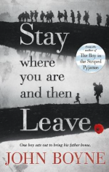  What are we fighting for?  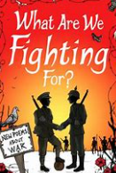 | Clockwork  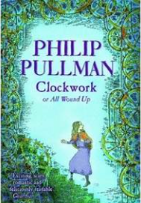  A Ghastly Waxwork (Bob Cox extract based on Miss Havisham – Great Expectations) | 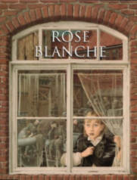  Rose Blanche  Letters from the Lighthouse  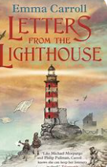 | 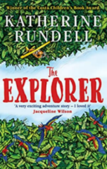  The Explorer  The Tyger  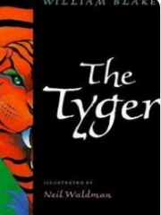 | 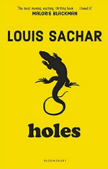  Holes  The Highwayman  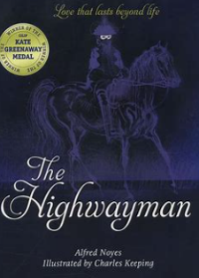 | Curiosity: The Story of a Mars Rover  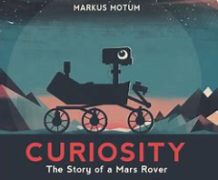  Unlocking the Universe  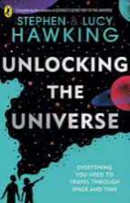
Author | John Boyne  Brian Moses | Philip Pullman | Ian McEwan  Emma Carroll | Katherine Rundell  William Blake | Louis Sachar  Alfred Noyes/Charles Keeping | Markus Motum  Stephen/Lucy Hawking
Theme | WW1 | Horror/Suspense | WW2 | South America | Crime and Punishment | Space
Literary form | Historical fiction  Poetry | Fiction  Classic fiction | Picture Book  Historical Fiction | Modern fiction  Poetry | Modern fiction  Poetry | Nonfiction picturebook
Linked texts  Picture books, poetry, Bob Cox extracts etc. | Armistice Runner  War Horse  Stories of the First World War  39 Steps  The Battle of Passchendaele  Walter Tull  War School for Dogs  Walter Tull’s Scrapbook  Archie’s War  Line of Fire – graphic novel  History through poetry – WW1  What are we fighting for?  The Silver Donkey  Where the Poppies Now Grow  Private Peaceful  Poems from the First World War | Woman in White – Wilkie Collins  Crater Lake  Room 13  Malamander  The Dream Snatcher  The Graveyard Book  The Viewer  Petrify  The Grey Ghost  Fearless Flynn  Nightmare: Two Ghostly Tales  Beneath the Waves  Still Water | Letters from the Lighthouse  D Day Dog  In Flanders Field  The Day War Came  Anne Frank – Josephine Poole  My Secret War Diary  The Silver Sword  Emergency Zoo  The Boy in the Striped Pyjamas  When Hitler Stole Pink Rabbit  The Boy at the Top of the Mountain  Friend or Foe  Goodnight Mr Tom  D-Day Dog  The War of Jenkins’ Ear  Carrie’s War  The Lion the Witch and the Wardrobe  Blitzed  (Various non-fiction supporting texts) | Journey to the River Sea  Survivors – The Girl Who Fell from the Sky  The Tyger  Trash  The Great Kapok Tree | Treason  The Adventures of Robin Hood  High-Rise Mystery  To be or not to Be from Hamlet (Blank verse) | An Adventurer’s Guide to Outer Space  The Mysteries of the Universe  Mars:Explore the Mysteries of the Red Planet  A Quick History of the Universe  Great Lives in Graphics: Stephen Hawking  Beyond the Sky: You and the Universe
National Curriculum Reading objectives | Word Reading:  Pupils should be taught to:  • use strategies such as recognising syllables /phonemes to decode new or unfamiliar words  • focus on all the letters in unfamiliar words so that they do not, for example, read ‘invitation’ for ‘imitation’ simply because they might be more familiar with the first word  • re-read, as needed to take account of especially challenging word order and phrasing  • read most words effortlessly and with increasing automaticity  • test out different plausible pronunciations for less familiar words  • [children should be able to read further exception words independently. If they are not able to do so, please refer to previous year groups]  • apply their growing knowledge of root words, prefixes and suffixes (morphology and etymology) as listed in English appendix 1, both to read aloud and to understand the meaning of new words that they meet  • read longer words, using syllable boundaries where needed  • [children should be able to read and understand words with contractions independently. If they are not able to do so, please refer to KS1]  • read aloud unfamiliar words or challenging sections of text, where needed, to support accuracy and automaticity  • re-read words or challenging sections of text to ensure understanding through fluency  • read age-appropriate texts fluently (including pausing appropriately, reading in phrases, responding to punctuation)  Comprehension:  Pupils should be taught to:  • Maintain positive attitudes to reading and understanding of what they read  • Understand what they read  • Discuss and evaluate how authors use language, including figurative language, considering the impact on the reader  • Retrieve, record and present information from non-fiction  • Distinguish between statements of fact and opinion  • Provide reasoned justification for their views  • Participate in discussions about books that are read to them and those they can read for themselves, building on their own and others’ ideas and challenging views courteously  • Explain and discuss their understanding of what they have read, including through formal presentations and debates, maintaining a focus on the topic and using notes where necessary  Further detail (from Herts for Learning) to support each comprehension objectives below:  Year 5  Pupils should be taught to maintain positive attitudes to reading and understanding of what they read by:  • continuing to listen to, read and discuss an increasingly wide range of fiction, poetry, plays, non-fiction and reference books or textbooks  • reading books that are structured in different ways and reading for a range of purposes  • empathising with different characters within a book considering actions, motivations, complexities and interactions with other characters  • identifying with, and exploring characters , using a range of drama techniques e.g. through role play, improvisation, using voice, gesture or movement, hot seating, freeze framing; role on the wall; conscience alley  • linking what they read or hear with known experiences in order to make sense of complex text  • increasing their familiarity with a wide range of books, including myths, legends and traditional stories, modern fiction, fiction from our literary heritage, and books from other cultures and traditions  • discussing the sequence of events in both linear and non-linear texts and how the different elements relate to one another within the text e.g. ’Story unfolds sequentially and rapidly with lots of detail and multiple events.’  • ‘Chapters change with the movement of the plot but are interspersed with the dream sequences.’  • identifying and discussing themes understanding family dynamics, courage over adversity, justice, perseverance, and conventions in a wide range of texts including narrative and non-fiction, poetry e.g. help coming in the form of an animal; the wise mentor  • recognise that a text may have multiple themes  • making comparisons within and across books e.g. characters, settings, themes, layout, structure  • discussing and clarifying the meanings of words, linking new meanings to known vocabulary  • continuing to use dictionaries to check the meanings of words that they have read  • identifying words and phrases which are unknown e.g. blurted; territory; carrion; neutral ground  • discussing words and phrases that capture the reader’s interest and imagination  • reading silently with good understanding, working out how to pronounce unfamiliar words  • recommending books that they have read to their peers, giving reasons for their choices  • internalising the rhythms/stresses of literary language e.g. caked with grime; faint, faraway roar; scent-laden winds and grammatical structures e.g. questions, a range of conjunctions, fronted adverbials  • learning a wider range of poetry by heart  • preparing poems and plays to read aloud and to perform, showing understanding through intonation, tone and volume so that the meaning is clear to an audience  • recognising some different forms of poetry  Pupils should be taught to understand what they read by:  • drawing on what they already know or on background information and vocabulary provided by the teacher  • checking that the text makes sense to them, discussing their understanding and exploring the meaning of words in context  • reading with appropriate expression through phrasing, stress and pitch  • responding to open questions and prompts e.g. tell me about…  • asking questions to improve their understanding, including through individual inner dialogue while reading and discussion after/during reading e.g. What would I do if I met scary people in an alleyway? How will he ever get back over the wall again?  • using tentative language to speculate on possibilities raised by the text e.g. What if another robot had also worked after the shipwreck? Perhaps Roz will make friends with the animals in the end.  • making connections (with experiences, other texts, elsewhere in the same text) in order to refine thoughts/responses e.g. Roz and the other animals don’t understand each other at all at the beginning. Then they start doing things with each other and try to solve problems – like when you’re in a new group and you start to see a different side of people and it’s easier to work with them.  • drawing inferences such as inferring characters’ feelings, thoughts and motives from their actions, and justifying inferences with evidence  • recognising that characters may have different perspectives in the story of the same event(s)  • making deductions about the motives and feelings that might lay behind characters’ words  • considering ways in which different settings influence the reader and/or the characters in the text  • predicting what might happen from details stated and implied  • exploring the likelihood of a suggestion being correct  • beginning to adapt predictions in the light of new information  • predicting how characters might behave, taking into account considerations such as motivations, events so far, atmosphere, relationships, settings, and levels of risk  • identifying key details that support the main ideas (gist)  • summarising the main ideas drawn from more than one paragraph  • beginning to summarise varying thoughts, actions, feelings and/or opinions within a text  • finding information efficiently using skimming and scanning strategies, and beginning to make annotations where appropriate  • retrieving information, referring to more than one place in the text where required  • identifying how language, structure and presentation contribute to meaning (see Assessing with Age-Related Texts for fiction examples)  for language:  o ‘Vitamins aren’t an optional extra.’  o ’Hunt was a military man who planned the expedition with absolute precision’  for structure:  o More detailed sections of texts, which involve greater use of a range of conjunctions, relative clauses, and passive constructions  for presentation:  o Increasingly complicated processes (e.g. water cycle; Viking sailing routes) illustrated with complex diagrams, with more complex labels and captions.  Pupils should be taught to discuss and evaluate how authors use language, including figurative language, considering the impact on the reader by:  • describing and evaluating the use of particular words or phrases, and their effect on the reader  • discussing language choices in the text that provides clues to the author’s intent  • discussing the meaning of figurative words and phrases (fiction and non-fiction)  • exploring the effect of imagery sustained within a paragraph  • beginning to discuss how writers create shades of meaning  • exploring synonyms and idiomatic language (often seemingly simple words working together for a particular meaning) e.g. ‘pricked his ears’ (Wolf Brother)  • exploring how the conventions of different types of writing (e.g. language features of specific genres and cohesive devices) are used to support the authors’ aims  • discussing the impact of authorial choices on the reader  Pupils should be taught to retrieve, record and present information from non-fiction by:  • identifying and discussing unknown technical or subject specific vocabulary with increasing independence  • using the navigational features of a range of texts and beginning to make choices about which would be most useful for retrieving the information required  • beginning to make comparisons between forms, layouts and the ways in which information is presented  • skimming and scanning a text to find specific information  • retrieving information from more than one section or aspect of a text e.g. headings, graphs, illustrations, subheadings  • identifying keywords and main points within and across texts  • recording information gained from reading in a variety of forms e.g. notes, mind maps, flow charts tables, bullet points and questions for further research  • presenting information gained from reading e.g. orally, individual or group written outcomes  Pupils should be taught to distinguish between statements of fact and opinion by:  • identifying facts within a text thinking about whether something is true/not true –real or imagined  • identifying opinions within a text e.g. viewpoints, beliefs  Pupils should be taught to provide reasoned justification for their views by:  • forming conclusions based on, or inferred from, evidence within the text e.g. Torak and Renn learn to trust each other and you see them become friends. They started out as sort of enemies because she was in the group when he was captured but their journey showed them they needed each other to survive.  • justifying their opinions, sometimes referring to more than one place in the text  • e.g. Renn only helps him when they first meet because it could help her clan. Then they find they have to work together to escape the bear. By the end, Torak will risk getting the last bit of the Nanuak to save his friend Renn.  • expressing and justifying personal preferences regarding authors/named books/poets/genres  Pupils should be taught to participate in discussions about books that are read to them and those they can read for themselves, building on their own and others’ ideas and challenging views courteously by:  • sustaining attentive listening, building on others’ ideas by agreeing or disagreeing  • challenging specific points within an argument for greater clarity/detail/accuracy  • beginning to draws on different points of view when responding  • asking questions for clarification and understanding)  • beginning to ask and answer open questions to explore a range of possibilities and justifies responses in relation to the text  • using tentative language (e.g. could it be?’, I wonder whether ..? ‘perhaps’, possibly) to aid speculative thinking and deepen understanding when considering a line of enquiry/dilemma  • presenting spoken arguments, making use of some discursive techniques, such as: sequencing points logically, defending views with evidence and making use of persuasive language  • developing, agreeing and evaluating rules for effective discussion  • beginning to act upon feedback to improve the quality of their explanations and contributions to discussions  • following up and build upon ideas under discussion  • challenging others’ views courteously  • considering possibilities and arriving at an agreement  • beginning to summarise main ideas from a discussion  Year 6  Pupils should be taught to maintain positive attitudes to reading and understanding of what they read by:  • continuing to listen to, read and discuss an increasingly wide range of fiction, poetry, plays, non-fiction and reference books or textbooks  • reading books that are structured in different ways and reading for a range of purposes  • empathising with a number of different characters within a book considering actions, motivations, complexities and interactions with other characters  • identifying with, and exploring characters , using a range of drama techniques e.g. through role play, improvisation, using voice, gesture or movement, hot seating, freeze framing; role on the wall; conscience alley  • linking what they read or hear with known experiences in order to make sense of complex text  • increasing their familiarity with a wide range of books, including myths, legends and traditional stories, modern fiction, fiction from our literary heritage, and books from other cultures and traditions  • discussing the sequence of events in both linear and non-linear texts and how they the different elements relate to one another within the text e.g. ‘A linear narrative with some flashbacks to the past, interspersed with occasional visits to ‘another world’.  • ‘Book moves between passages dominated by third person narration and stretches where characters and dialogue move the plot forward.’  • Identifying and discussing themes e.g. resilience, differing responses to hardship or danger, belonging, relationships between people and wildlife, and conventions in a wide range of texts in a wide range of narrative, non-fiction and poetry e.g. symbolic objects; movement between dimensions  • recognise where a text may have multiple themes  • making comparisons within and across books e.g. characters, settings, themes, layout, structure  • discussing and clarifying the meanings of words, linking new meanings to known vocabulary  • continuing to use dictionaries to check the meanings of words that they have read  • identifying words and phrases which are unknown e.g. abruptly, requisitioner; tendrils; hind feet dragging  • discussing words and phrases that capture the reader’s interest and imagination  • reading silently with good understanding, working out how to pronounce unfamiliar words  • internalising the rhythms/stresses of literary language e.g. snow-covered branches; dance and drift; spread like a heath fire and grammatical structures e.g. questions, a range of conjunctions, fronted adverbials  • learning a wider range of poetry by heart  • preparing poems and plays to read aloud and to perform, showing understanding through intonation, tone and volume so that the meaning is clear to an audience  • recognising some different forms of poetry, recommending books that they have read to their peers, giving reasons for their choices  • identifying how language, structure and presentation contribute to meaning (see Assessing with Age-Related Texts for fiction examples) for language:  o ‘Darwin thought evolution by Natural Selection was gradual and ongoing’  o ‘With our ever-increasing modern knowledge,e it came to pass…’  for structure:  o More extended blocks of text, featuring more technical tier 3 language. Passive constructions and address content succinctly but add to density.  for presentation:  o Text dominates. Illustration may not serve major points and instead address interesting or curious elements. Illustrations more decorative than explanatory (outside of process diagrams)  Pupils should be taught to discuss and evaluate how authors use language, including figurative language, considering the impact on the reader by:  • describing and evaluating the use of particular words or phrases, and their effect on the reader  • discussing language choices in the text that provides clues to the author’s intent  • discussing the meaning of figurative words and phrases (fiction and non-fiction)  • exploring the effect of imagery sustained within and across paragraphs  • discussing how writers create shades of meaning  • exploring synonyms and idiomatic language (often seemingly simple words working together for a particular meaning) e.g. ‘ pick up speed' (House with Chicken Legs)  • exploring how the conventions of different types of writing (e.g. language features of specific genres and cohesive devices) are used to support the authors’ aims  • discussing the impact of authorial choices on the reader  Pupils should be taught to retrieve, record and present information from non-fiction by:  • exploring and discussing unknown technical or subject specific vocabulary with increasing independence  • using the navigational features of a range of texts and making choices about which would be most useful for retrieving the information required  • making comparisons between forms, layouts, and the ways in which information is presented  • skimming and scanning a range of texts to find specific information  • retrieving information from several sections or aspects of a text e.g. headings, graphs, illustrations, subheadings  • identifying keywords and main points within and across texts  • recording information gained from reading in a variety of forms e.g. notes, mind maps, flow charts tables, bullet points and questions for further research  • presenting information gained from reading e.g. orally, individual or group written outcomes  Pupils should be taught to distinguish between statements of fact and opinion by:  • identifying facts within a text and beginning to recognise that opinions are sometimes presented as facts  • identifying opinions within a text e.g. viewpoints, beliefs and beginning to identify varying opinions  Pupils should be taught to provide reasoned justification for their views by:  • forming conclusions based on, or inferred from, evidence within the text e.g. Jan does things that you know are wrong, like telling lies, but there are lots of clues that his life must have been awful when he was younger and he must have had to do bad things to survive.  • justifying their opinions, referring to more than one place in the text where appropriate e.g. Jan can’t get out of his bad habits because he’s been living that way for so long. He steals food for the children when they can’t get it any other way, but then  • he carries on when he doesn’t need to any longer – like when they’re in the American unit and the Captain says, it’s become a habit.  • expressing and justifying personal preferences regarding authors/named books/poets/genres  Pupils should be taught to participate in discussions about books that are read to them and those they can read for themselves, building on their own and others’ ideas and challenging views courteously by:  • sustaining attentive listening, building on others’ ideas by agreeing or disagreeing  • challenging specific points within an argument for greater clarity/detail/accuracy  • drawing on different points of view when responding  • asking questions for clarification and understanding)  • asking and answering open questions to explore a range of possibilities and justifies responses in relation to the text  • using tentative language (e.g. could it be? I wonder whether?’, ‘perhaps’, possibly) to aid speculative thinking and deepen understanding when considering a line of enquiry/dilemma  • presenting spoken arguments, making use of a range of discursive techniques, such as: sequencing points logically, defending views with evidence and making use of persuasive language  • developing, agreeing and evaluating rules for effective discussion  • acting upon feedback to improve the quality of their explanations and contributions to discussions

