Year: 3/4 A | Autumn 1 | Autumn 2 | Spring 1 | Spring 2 | Summer 1 | Summer 2
Book  (Main Driver Text) | Our Tower  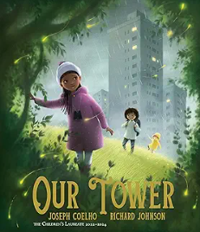 | Walter Tull’s Scrapbook  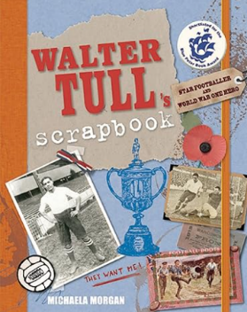 | 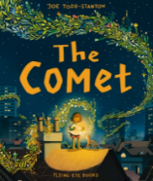  The Comet  Moon Juice  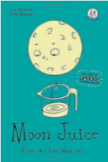 | Cinderella of the Nile  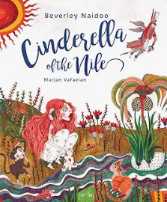 | 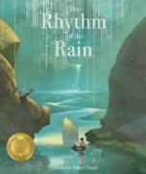  Rhythm of the Rain  Water  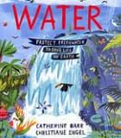 | Charging About: The Story of  Electricity  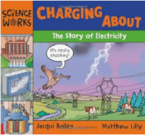  Greek Myths – Midas  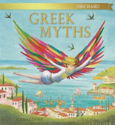
Author | Joseph Coelho | Michaela Morgan | Joe Todd-Stanton  Kate Wakeling | Beverly Naidoo | Grahame Baker-Smith  Catherine Barr | Jaqui Bailey
Theme | Community light/dark | Heroism/Bravery  Racism | Growing and Changing | Resilience  Egyptians | Water/Rivers | Ancient Greece
Literary form | Adventure story | Fictionalised autobiography | Picturebook  Poetry | Fable/Fairy tale | Non-fiction | Non-fiction  Myth
Linked texts | If all the world were  Poems aloud  Budgie  Tar Beach  Footpath Flowers  Home  Window  Belonging  Lost in the City | Archie’s War  Where the Poppies Now Grow  Flo of the Somme  The Christmas Truce  The Silver Donkey | Krindlekrax  Grandpa Green  Changes  The Proudest Blue  Window/Belonging  Red Sky at Night: Poet’s Delight  I Don't like poetry  The Book of not entirely useful advice  The Shape of Rainbows  Other Joe TS books:  The Secret of Black Rock  A Mouse Called Julian | Cinderella Liberator  The Egyptian Cinderella  My Nine Lives by Clio  Flat Stanley: The Great Egyptian Grave Robbery  Secrets of a Sun King  Marcy and the Riddle of the Sphinx  Mummies Unwrapped | The River Story – Meredith Hooper  A River – Marc Martin  Flood (pb) – Alvaro Villa  The River (f)  Once Upon a Raindrop (nf/p)  Wind in the willows  Water Cycles - DK | Who Let the Gods Out  Mythologica – encyclopaedia  Greek Myths and Mazes  FArTHER  Ancient Greeks (nf)  Greek Myths (Marcia Williams) (nf)  Falling out of the Sky (p)

Year: 3/4 B | Autumn 1 | Autumn 2 | Spring 1 | Spring 2 | Summer 1 | Summer 2
Book  (Main Driver Text) | 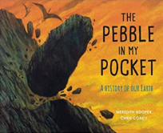  The Pebble in my Pocket  The Secrets of Stonehenge  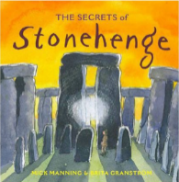 | The Steadfast Tin Soldier  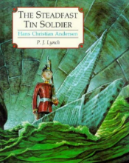  The Robot and the Bluebird  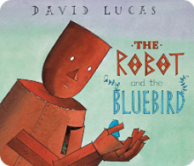 | Blue John  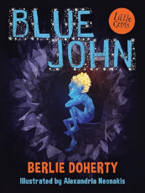  The King Who Banned the Dark  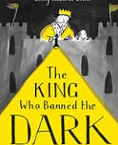 | The Tear Thief    The Language of Cat (p)  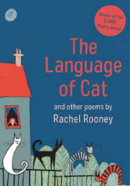 | The Adventures of the Dish and the Spoon  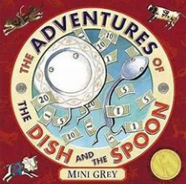 | Escape from Pompeii  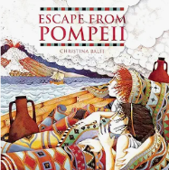  Earth Shattering Events  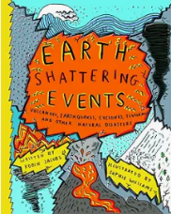
Author | Meredith Hooper  Mick Manning | Naomi Lewis | Berlie Doherty | Carol Ann Duffy  Rachel Rooney | Mini Grey | Christina Balit  Sophie Williams
Theme | Stone Age | Overcoming fear | Fear/light and dark | Moral dilemmas  family | Mini Grey | Extreme Earth
Literary form | Narrative non-fiction  Non-fiction | Classic fiction/fairy tale  Fiction | Fiction | Fiction  Poetry | Picturebook | Historical Fiction  Non-fiction
Linked texts | A Stone for Sascha  Stone Age Boy  Ugg: Boy Genius of Stone Age  Dave’s Cave/Dave’s Rock  The Stone Age Tablet  Stone Age, Bone Age!  When We Became Humans  A Rock is Lively  The Street Beneath My Feet  What a Rock can Reveal  Under your Feet: Soil, Sand and other stuff | The Robot and the Blue Bird  Iron Man – Ted Hughes  The Wild Robot  The Miraculous Journey of Edward Tullane  Little Home Bird  Runaway Robot  Hands Christian Andersen – Stories and Fairytales | Snow Queen  Journey  Quest  The Dark  Flashlight  The Pebble in my Pocket | The Lost Happy Endings  The Colour Monster  The Heart and the Bottle – Oliver Jeffers  T.S. Eliot – Old Possum’s book of Practical Cats | Mini Grey books:  Traction Man  The Last Wolf (ks1)  Biscuit Bear  Toys in Space  The Greatest Show on Earth  Hermelin | Volcanoes non-fiction  The Firework Maker’s Daughter  Roman Mysteries – The Secrets of Vesuvius  Roman Fort nf – Nick Manning  Empire’s End – A Roman Story (Leila Rasheed) diversity  Real Life Disasters – Mega eruption  Earth Shattering Earthquakes  Natural disaster books
Reading objectives | Word Reading:  Pupils should be taught to:  - continue to apply phonic knowledge and skills as the route to decode words which are outside their spoken vocabulary  - use strategies such as recognising syllables /phonemes to decode most new words outside their spoken vocabulary (Y4 only)  - match what they decode to words they may have already heard but may not have seen in print [for example, in reading ‘technical’, the pronunciation /tɛtʃnɪkəl/ (‘tetchnical’) might not sound familiar, but /tɛknɪkəl/ (‘teknical’) should]  - re-read and refine reading of phrases or clauses that are tricky to read aloud smoothly on first attempt so that fluency is improved  - read most words accurately and at a speed that is sufficient for them to focus on understanding what they read rather than on decoding individual words  - test out different plausible pronunciations for less familiar words  - read further exception words, noting the unusual correspondences between spelling and sound, and where these occur in the word  - apply their growing knowledge of root words, prefixes and suffixes (etymology and morphology) as listed in English appendix 1, both to read aloud and to understand the meaning of new words they meet  - read longer words, using syllable boundaries (where needed Y4) and reading each syllable separately before they combine them to read the word  - [children should be able to read and understand words with contractions independently. If they are not able to do so, please refer to previous year groups.]  - read aloud unfamiliar words or challenging sections of text, where needed, to support accuracy and automaticity  - re-read words or challenging sections of text to ensure understanding through fluency  - read age-appropriate texts fluently (including pausing appropriately, reading in phrases, responding to punctuation)  Comprehension:  Pupils should be taught to:  - Develop positive attitudes to reading and understanding of what they read by (Y3 & Y4)  - Understand what they read, in books they can read independently, by (Y3 & Y4)  - Discuss how authors use language, including figurative language, considering the impact on the reader (Y3 & Y4)  - Retrieve and record information from non-fiction (Y3 & Y4)  - Distinguish between statements of fact and opinion (Y3 & Y4)  - Begin to provide reasoned justification for their views (Y4)  - Participate in discussion about both books that are read to them and those they can read for themselves, taking turns and listening to what others say (Y3 & Y4)  - Explain and discuss their understanding of books, poems and other material, both those that they listen to and those that they read for themselves (Y3 & Y4)  Further detail (from Herts for Learning) to support each comprehension objectives below:  Year 3  Pupils should be taught to develop positive attitudes to reading and understanding of what they read by:  • listening to, reading and discussing a wide range of fiction, poetry, plays, non-fiction and reference books or text books  • reading books that are structured in different ways and reading for a range of purposes  • empathising with characters, based on their descriptions and actions  • identifying with, and exploring characters , using a range of drama techniques e.g. through role play, improvisation, using voice, gesture or movement, hot seating, freeze framing; role on the wall; conscience alley  • linking what they read or hear with their own experiences and beginning to link with others’ experiences  • increasing their familiarity with a wide range of books, including fairy stories, myths and legends, and retelling some of these orally  • discussing the sequence of events in texts and how items of information are related  • identifying common themes e.g. friendship, school life, sibling rivalry and conventions e.g. use of magic objects, good overcoming evil, a bad character learning a lesson and overcoming their behaviour in a wide range of texts  • making comparisons within a book e.g. characters, settings  • discussing and clarifying the meanings of words, linking new meanings to known vocabulary  • using dictionaries to check the meanings of words that they have read  • identifying words and phrases which are unknown e.g. scrambled; potion; glanced; mangy old parrot  • discussing words and phrases that capture the reader’s interest and imagination  • sustaining interest in longer narratives  • reading silently with good understanding  • asking for help with unfamiliar pronunciations and meanings  • beginning to recommend books that they have enjoyed to their peers  • beginning to respond to literary language by phrasing appropriately when reading aloud e.g puffed himself up like a turkey; rang with the sound of hobnailed boots; shouts rent the air  • beginning to internalise rhythms/ stresses signalled by grammatical structures e.g. questions, conjunctions  • building upon a repertoire of poems learnt by heart  • preparing poems and play scripts to read aloud and to perform, showing understanding through intonation, tone, volume and action  • recognising some different forms of poetry  Pupils should be taught to understand what they read, in books they can read independently, by:  • drawing on what they already know or on background information and vocabulary provided by the teacher  • checking that the text makes sense to them, discussing their understanding and explaining the meaning of words in context  • reading with appropriate expression through phrasing, stress and pitch  • responding to open questions and prompts e.g. tell me about…  • asking questions to improve their understanding of a text, including through individual inner dialogue while reading and discussion after/during reading e.g. How would I feel if I suddenly developed a superpower? Why did the brother and sister join forces in America?  • using tentative language to speculate on possibilities raised by the text e.g. After the competition with the strong man, Josie could ... We know Mr Two-suit likes money, what else might he be after?  • making connections (with experiences and other texts) in order to refine thoughts/responses e.g. Mildred’s spells go wrong and it’s funny but it’s also embarrassing for her, like when I first tried riding my bike and couldn’t do it. I’ve read other books where children have to make new friends in a new place. It’s hard at first but then they do it.  • drawing inferences such as inferring characters’ feelings, thoughts and motives from their actions, and justifying inferences with evidence  • beginning to recognise that characters may have different perspectives in the story of the same event(s)  • recognising that settings may affect feelings and behaviours  • beginning to consider how setting descriptions may affect the reader  • predicting what might happen from details stated and implied  • beginning to indicate the likelihood of a suggestion being correct  • predicting how characters might behave, thinking about events so far, settings and beginning to consider changes in atmosphere  • recalling and sequencing main events from a text  • identifying main ideas (gist) drawn from more than one paragraph  • beginning to summarise main ideas drawn from more than one paragraph  • beginning to use skimming and scanning strategies  • retrieving information from the text then checking the selection is what is required  • beginning to select related information from more than one place in a text  • identifying how language structure and presentation contribute to meaning (see Assessing with Age-Related Texts for fiction examples)  for language:  o ‘After many more years of trading and travelling…’; ‘kept heading east’  for structure:  o Use of increasing range of adverbials and prepositions to provide greater detail  about when, where and how things happen.  for presentation: Events are supported by illustrations.  Pupils should be taught to discuss how authors use language, including figurative language, considering the impact on the reader by:  • discussing the way descriptive language and small details are used to create an impression for the reader  • discussing the meaning of figurative words and phrases (fiction and non-fiction)  • exploring synonyms and idiomatic language (often seemingly simple words working together for a particular meaning e.g. ‘Give me a break!’ (Strongest Girl in the World))  Pupils should be taught to retrieve and record information from non-fiction by:  • collecting and discussing unknown technical or subject specific vocabulary  • using features such as: contents, index, headings and links within a web page to navigate a text  • re-reading to find specific information in a non-fiction text  • retrieving information from specified aspects of a text e.g. headings, graphs, illustrations, subheadings  • identifying keywords and main points within the text  • recording information gained from reading in a variety of simple forms e.g. notes, mind maps, flow charts and tables  Pupils should be taught to begin to provide reasoned justification for their views by:  • justifying their views about what they have read or have had read to them referring back to the text for evidence e.g. Ethel seems to be very clever but she’s not very nice because she’s often mean to Mildred when her spells don’t work.’  • expressing and justifying personal preferences regarding authors/named books/poets/genres  Pupils should be taught to participate in discussion about both books that are read to them and those they can read for themselves, taking turns and listening to what others say by:  • listening and making relevant, related comments  • commenting or asking for an explanation  • beginning to recognise that opinions may change as a result of listening attentively to others  • asking questions for clarification and understanding  • posing ‘what if?’ questions that may change the outcome or direction of the line of enquiry/dilemma  • participating and speaking audibly in a range of situations  • beginning to use evidence to defend points of view  • beginning to develop, agree and evaluate rules for effective discussion  • taking turns in group or class conversations  • beginning to follow up others’ points  • showing whether they agree or disagree in a group or whole-class discussion  Pupils should be taught to explain and discuss their understanding of books, poems and other material, both those that they listen to and those that they read for themselves by:  • expressing ideas showing understanding of what has been read  • beginning to develop clarity of personal responses  • explaining or giving reasons for their views or choices, referring to the context and offering evidence to support their opinion  • explaining to others what they have read or found out  • beginning to provide a summary of what has been read or found out for own and others’ use  Year 4  Pupils should be taught to develop positive attitudes to reading and understanding of what they read by:  • listening to, reading and discussing a wide range of fiction, poetry, plays, non-fiction and reference books or text books  • reading books that are structured in different ways and reading for a range of purposes  • empathising with different characters within a book considering actions and interactions with other characters  • identifying with, and exploring characters , using a range of drama techniques e.g. through role play, improvisation, using voice, gesture or movement, hot seating, freeze framing; role on the wall; conscience alley  • linking what they read or hear with their own and others’ experiences and beginning to use these to make sense of more complex texts  • increasing their familiarity with a wide range of books, including fairy stories, myths and legends, and retelling some of these orally  • discussing the sequence of events in texts and how items of information are related, and beginning to consider non-linear texts, e.g. ‘demanding plot unfolds sequentially with a number of additional subplots fleshing out the story.’  • ‘Shift from Wiltshire to South African veld presents some challenge, as does the shift to World War’  • identify themes e.g. friendship and separation, animal welfare, conquering fears, and conventions in a wide range of texts including narrative and poetry e.g. overcoming a common enemy, magical objects  • recognise that a text may have multiple themes  • making comparisons within a book e.g. characters, settings, themes  • discussing and clarifying the meanings of words, linking new meanings to known vocabulary  • using dictionaries to check the meanings of words that they have read  • identifying words and phrases which are unknown e.g. windblown; veranda; nightwatchman; piercing dark eyes  • discussing words and phrases that capture the reader’s interest and imagination  • reading silently with good understanding  • asking for help with unfamiliar pronunciations and meanings  • beginning to recommend books that they have enjoyed to their peers, sometimes giving reasons for their choices  • responding to literary language by phrasing appropriately when reading aloud e.g. sidled back into the picture; kite swirled crazily away; dragged interminably  • continuing to internalise rhythms/ stresses signalled by grammatical structures e.g. questions, conjunctions, fronted adverbials  • building upon a repertoire of poems learnt by heart  • preparing poems and play scripts to read aloud and to perform, showing understanding through intonation, tone, volume and action  • recognising some different forms of poetry  Pupils should be taught to understand what they read, in books they can read independently, by:  • drawing on what they already know or on background information and vocabulary provided by the teacher  • checking that the text makes sense to them, discussing their understanding and explaining the meaning of words in context  • reading with appropriate expression through phrasing, stress and pitch  • responding to open questions and prompts e.g. tell me about…  • asking questions to improve their understanding of a text, including through individual inner dialogue while reading and discussion after/during reading e.g. What if I could make objects levitate? Why didn’t Harry run away from the Dursley’s?  • using tentative language to speculate on possibilities raised by the text e.g. I wonder what magical animal Harry would have had, if Hagrid hadn’t bought him an owl? Possibly Harry could be feeling ... when McGonagall took him inside after the flying lesson.  • making connections (with experiences and other texts) in order to refine thoughts/responses e.g. When Bertie finds his lion again - when they’re in the war, it felt sad and happy at the same time. Like when your lost pet comes back, or when the Ugly Duckling finds he’s a swan.  • drawing inferences such as inferring characters’ feelings, thoughts and motives from their actions, and justifying inferences with evidence  • recognising that characters may have different perspectives in the story of the same event(s)  • making deductions about the motives and feelings that might lay behind characters’ words  • beginning to consider ways in which different settings affect the characters  • considering how setting descriptions may influence the reader  • predicting what might happen from details stated and implied  • indicating the likelihood of a suggestion being correct  • predicting how characters might behave, considering motivation, events so far, settings and atmosphere  • recalling and sequencing main events from a text  • identifying main ideas (gist) drawn from more than one paragraph  • summarising main ideas drawn from more than one paragraph  • using skimming and scanning strategies  • making precise selections when retrieving information  • selecting related information from more than one place in a text  • identifying how language, structure and presentation contribute to meaning (see Assessing with Age-Related Texts for fiction examples)  for language:  o ‘Those fearsome raiders were warriors known as Vikings’ ‘Like many Anglo-Saxons at the time, …’  for structure:  o Increased use of synonymous words and phrases to refer to key elements and concepts (e.g. warriors, raiders, intruders). More developed blocks of text with a range of multiclause sentences.  for presentation:  o Fewer illustrations to illustrate elements from the text.  o In non-fiction, illustrations are often accompanied by detailed captions.  Pupils should be taught to discuss how authors use language, including figurative language, considering the impact on the reader by:  • discussing the way descriptive language and small details are used to create an impression for the reader  • beginning to evaluate the use of particular words or phrases, and their effect on the reader  • discussing the meaning of figurative words and phrases (fiction and non-fiction)  • beginning to explore the effect of imagery sustained within a paragraph  • exploring synonyms and idiomatic language (often seemingly simple words working together for a particular meaning) e.g. ‘ parted the crowd easily’ (Harry Potter and The Philosopher’Stone)  • beginning to discuss how the conventions of different types of writing (e.g. language features of specific genres and cohesive devices) are used to support the authors’ aims  • considering language chosen by the author to influence the reader’s feelings  Pupils should be taught to retrieve and record information from non-fiction by:  • identifying and discussing unknown technical or subject specific vocabulary  • using features such as: contents, index, headings and links within a web page to navigate a text  • beginning to make decisions about which of the above would be the most useful for retrieving the information required  • beginning to skim and scan a text to find specific information  • retrieving information from different sections or aspects of a text e.g. headings, graphs, illustrations, subheadings  • identifying keywords and main points within texts  • recording information gained from reading in a variety of simple forms e.g. notes, mind maps, flow charts and tables  Pupils should be taught to distinguish between statements of fact and opinion by:  • beginning to identify facts within a text thinking about whether something is true/not true –real or imagined  • beginning to identify opinions within a text e.g. viewpoints, beliefs  Pupils should be taught to begin to provide reasoned justification for their views by:  • beginning to reason by justifying their views about what they have read or have had read to them sometimes referring to more than one place in the text e.g. ‘After such a long and dangerous journey, Ivan must have felt so happy at first to see the dance but then so upset that it wasn’t real.’  • expressing and justifying personal preferences regarding authors/named books/poets/genres  Pupils should be taught to participate in discussion about both books that are read to them and those they can read for themselves, taking turns and listening to what others say by:  • listening and making relevant, related comments  • commenting or asking for an explanation  • understanding that you may sometimes need to change your opinion as a result of listening attentively to others  • asking questions for clarification and understanding  • posing ‘what if?’ questions that may change the outcome or direction of the line of enquiry/dilemma  • participating and speaking audibly in a range of situations  • beginning to make use of discursive techniques such as: defending views with evidence and making use of persuasive language  • developing, agreeing and evaluating rules for effective discussion  • taking turns in group or class conversations  • following up others’ points  • showing whether they agree or disagree in a group or whole-class discussion  • identifying key points following a discussion  Pupils should be taught to explain and discuss their understanding of books, poems and other material, both those that they listen to and those that they read for themselves by:  • expressing ideas showing understanding of what has been read  • developing clarity of personal responses  • explaining or giving reasons for their views or choices, referring to the context and offering evidence to support their opinion  • beginning to rephrase evidence from the context  • providing a summary of what has been read or found out for own and others’ use  • explaining to others what they have read or found out and begin to share views with justification

